List of Practical :
1. Familiarization with Raspberry Pi and perform necessary software installation.
Answer:
- Download and Install Raspberry Pi Imager 2.0
Go to the official website (raspberrypi.com/software) and download the latest version of Raspberry Pi Imager for your operating system (Windows, macOS, or Linux).
Run the installer, follow the on-screen prompts, and launch the program.
- Prepare Your SD Card
Insert a microSD card (minimum 32GB, Class 10 or faster recommended).
For best performance, use official Raspberry Pi cards, SanDisk Ultra, or SanDisk Extreme.
- Launch the Imager and Start the Wizard
Open Raspberry Pi Imager 2.0. The new interface guides you through each step sequentially.
- Select Your Raspberry Pi Device
Choose the exact model you are using (e.g., Raspberry Pi 5, Raspberry Pi 4, etc.). This helps the tool apply the correct default settings.
- Choose the Operating System
Select Raspberry Pi OS.
  - Choose the 64-bit version for better performance (recommended for Raspberry Pi 4 and 5).
  - Choose the 32-bit version for maximum software compatibility on older models.
You can also select Lite versions or other operating systems if needed.
- Select the Storage Device (SD Card)
Choose your inserted microSD card from the list.
Important: Double-check that you have selected the SD card and not your computer’s hard drive. Enable the “exclude system drives” option if available to prevent mistakes.
All data on the selected card will be erased.
- Configure System Settings (New Feature)
Complete the following configuration steps in the wizard:
  - Set Location & Language: Choose your country, language, and time zone.
  - Set Hostname: Give your Raspberry Pi a custom network name (example: raspberrypi-desk).
  - Create User Account: Set a new username and a strong password. (There is no longer a default “pi” user.)
  - Configure Wi-Fi: Enter your wireless network name (SSID) and password so the Pi connects automatically on first boot.
  - Enable Remote Access: Turn on SSH for command-line remote access. Choose password or public-key authentication.
  - Set Up Raspberry Pi Connect: Create or sign in to a Raspberry Pi account to enable easy cloud-based remote desktop access without port forwarding.
- Review and Write the Image
Review all your settings.
Click Write. The Imager will download the OS (if needed), write it to the SD card, and verify the data. This may take several minutes.
- Complete the Process
Then the writing

2. Run python program on Pi having problem statement: word and character count of a given string.
Answer: Python Program
# Word and Character Count Program
text = input("Enter a string: ")
# Count words
word_count = len(text.split())
char_count = len(text)
print("Number of Words:", word_count)
print("Number of Characters:", char_count)

Sample Output
Enter a string: Welcome to Raspberry Pi
Number of Words: 4
Number of Characters: 23
To Run on Raspberry Pi
- Open Terminal.
- Create a file:
- nano word_char_count.py
- Paste the code and save (Ctrl + X, Y, Enter).
- Run the program:
python3 word_char_count.py

3. Exercise on working principle of Raspberry Pi.with 40 PIN Interface component.
Reference Link: https://wokwi.com/projects/393048863616453633
Solution:
void setup() {
pinMode(15,INPUT);
Serial1.begin(115200);
Serial1.println("Hello, Raspberry Pi Pico!");
}

void loop(){
int pir = digitalRead(15);
if(pir == HIGH)
{
Serial1.println("MOVEMENT DECTECTED");
delay(500);
}
else
{
Serial1.println("NO MOVEMENT DECTECTED");
delay(500);
}
}
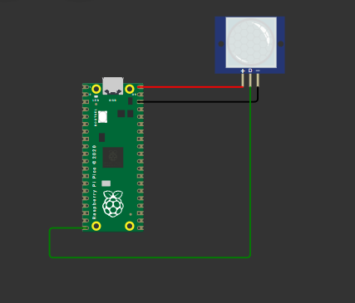

4. To interface Bluetooth with Raspberry Pi and write a program to turn LED ON/OFF when 1/0 is received form smartphone using Bluetooth
Note: Required Physical Device
Reference Link: https://iot-amrt.vlabs.ac.in/exp/bluetooth-led-control-pi/index.html
Connection
- Connect VCC of HC-05 Bluetooth module to VBUS (5V) of Raspberry Pi Pico.
- Connect TXD of HC-05 to GP0 of Raspberry Pi Pico.
- Connect RXD of HC-05 to GP1 of Raspberry Pi Pico.
- Connect GND of HC-05 to GND of Raspberry Pi Pico.
- Connect the positive terminal of the LED to the resistor.
- Connect the other terminal of the resistor to GP19 of Raspberry Pi Pico.
- Connect the negative terminal of the LED to GND of Raspberry Pi Pico.
- Click the Bluetooth icon on the smartphone to enable Bluetooth.
- Turn on Bluetooth by clicking the switch on the smartphone screen.
- Select Raspberry Pi from available devices to pair.
- After pairing, use the smartphone buttons to turn the LED on or off.
Python Program:
from machine import Pin, UART

uart = UART(0, 9600)
led = Pin(19, Pin.OUT)

while True:
if uart.any():
command = uart.readline()
if command == b'ON':
led.high()
print("LED ON")
elif command == b'OFF':
led.low()
print("LED OFF")

Devices: Raspberry Pi Pico, HC-05, Resistor, LED, Smartphone
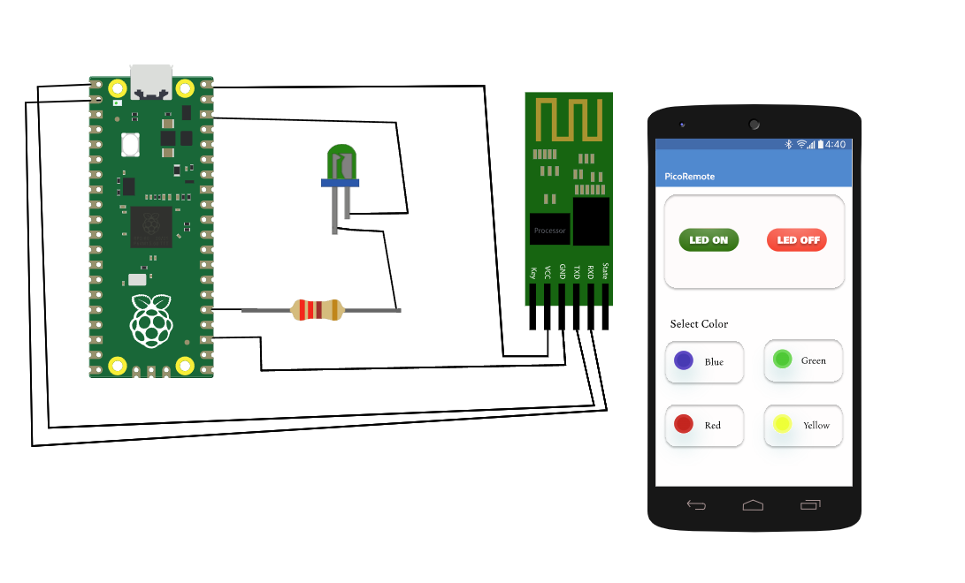

5. Connect with the Available Wi-Fi Using Arduino
Note: Required Physical Device
Reference Link: https://wokwi.com/projects/356552645200576513

#include <WiFi.h>

// Replace with your network credentials (STATION)
#define ssid "Wokwi-GUEST"
#define password ""

void initWiFi() {
WiFi.mode(WIFI_STA);
WiFi.begin(ssid, password);
// WiFi.begin("Wokwi-GUEST", "");
Serial.print("Connecting to WiFi ..");
while (WiFi.status() != WL_CONNECTED) {
Serial.println(WiFi.status());
Serial.print('.');
delay(1000);
}
Serial.println("Connected");
Serial.println(WiFi.status());
Serial.println(WiFi.localIP());
Serial.print("RRSI: ");
Serial.println(WiFi.RSSI());
}

void setup() {
Serial.begin(115200);
initWiFi();
}

void loop() {
// put your main code here, to run repeatedly:
}
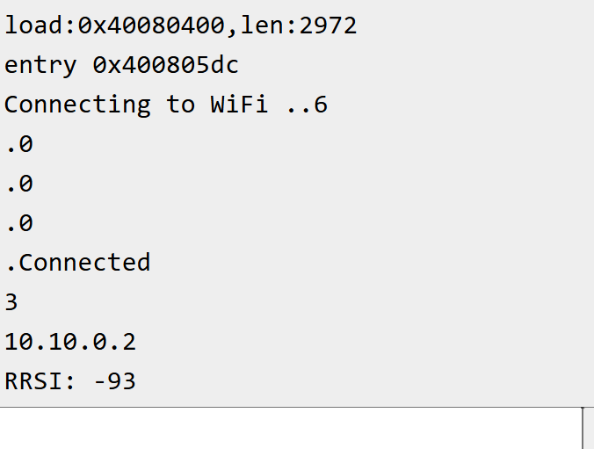

6. Write a program on Raspberry Pi to retrieve temperature and humidity data from thingspeak cloud
New: https://wokwi.com/projects/469089414257926145
import network, urequests, time

# ---------- WiFi ----------
wlan = network.WLAN(network.STA_IF)
wlan.active(True)
wlan.connect("Wokwi-GUEST", "")
while not wlan.isconnected():
time.sleep(0.5)
print("WiFi connected\n")

# ---------- ThingSpeak settings ----------
# Public demo channel (works out of the box, no key needed)
CHANNEL_ID = "12397"
READ_KEY = ""
TEMP_FIELD = "field4" # temperature on demo channel
HUM_FIELD = "field3" # humidity on demo channel

# ---------- Build the READ url (do not change) ----------
URL = "https://api.thingspeak.com/channels/" + CHANNEL_ID + "/feeds/last.json"
if READ_KEY:
URL += "?api_key=" + READ_KEY

# ---------- Main loop ----------
while True:
try:
r = urequests.get(URL)
data = r.json()
r.close()

if isinstance(data, dict):
print("Time :", data.get("created_at"))
print("Temp :", data.get(TEMP_FIELD))
print("Humidity:", data.get(HUM_FIELD))
print("-" * 30)
else:
print("Bad channel ID / key, server said:", data)
except Exception as e:
print("Network error:", e)

time.sleep(20)
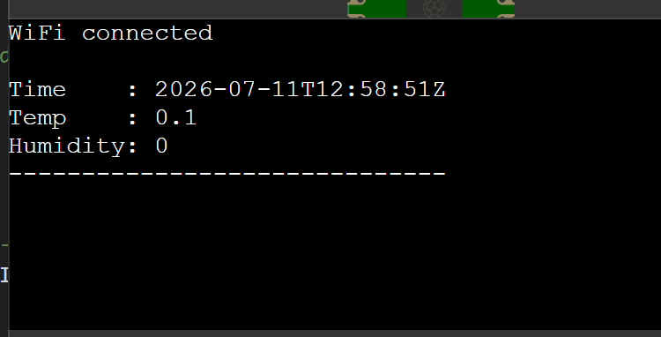

7. Write a program on Raspberry Pi to publish temperature data to MQTT broker.
Reference Link: https://wokwi.com/projects/322577683855704658
import network
import time
from machine import Pin
import dht
import ujson
from umqtt.simple import MQTTClient

# MQTT Server Parameters
MQTT_CLIENT_ID = "micropython-weather-demo"
MQTT_BROKER = "broker.mqttdashboard.com"
MQTT_USER = ""
MQTT_PASSWORD = ""
MQTT_TOPIC = "wokwi-weather"

sensor = dht.DHT22(Pin(15))

print("Connecting to WiFi", end="")
sta_if = network.WLAN(network.STA_IF)
sta_if.active(True)
sta_if.connect('Wokwi-GUEST', '')
while not sta_if.isconnected():
print(".", end="")
time.sleep(0.1)
print(" Connected!")

print("Connecting to MQTT server... ", end="")
client = MQTTClient(MQTT_CLIENT_ID, MQTT_BROKER, user=MQTT_USER, password=MQTT_PASSWORD)
client.connect()

print("Connected!")

prev_weather = ""
while True:
print("Measuring weather conditions... ", end="")
sensor.measure()
message = ujson.dumps({
"temp": sensor.temperature(),
"humidity": sensor.humidity(),
})
if message != prev_weather:
print("Updated!")
print("Reporting to MQTT topic {}: {}".format(MQTT_TOPIC, message))
client.publish(MQTT_TOPIC, message)
prev_weather = message
else:
print("No change")
time.sleep(1)

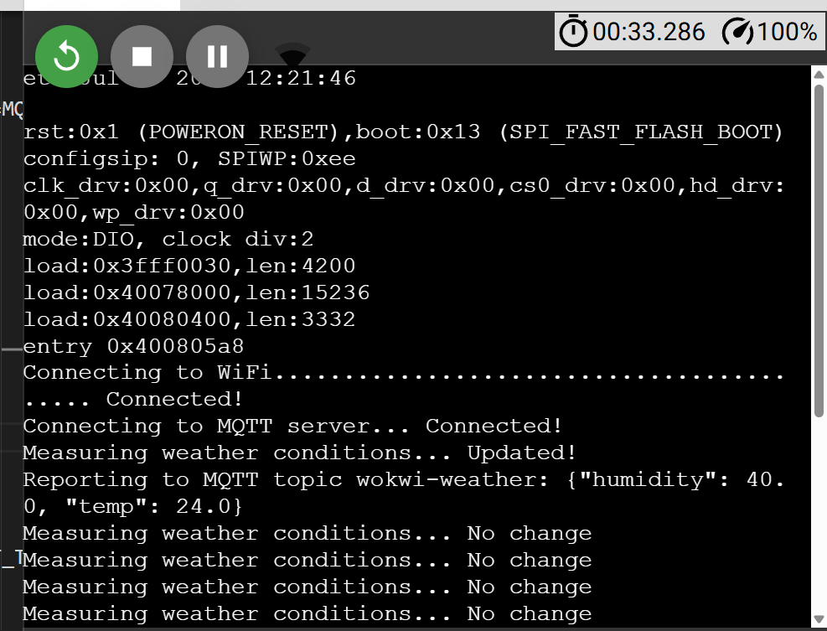

8. Connect Raspberry Pi with your existing system components.
Reference Link: https://wokwi.com/projects/357627199664450561
# Project objective: To test a passive buzzer to play an alarm sound at one second interval
#
# Hardware and connections used:
# Passive buzzer GND to Raspberry Pi Pico GND
# Passive buzzer + Pin to GPIO Pin 15
#
# Programmer: Adrian Josele G. Quional

# if passive buzzer is used, import the Speaker class from picozero
from picozero import Speaker
from time import sleep

# creating a Speaker object
speaker = Speaker(15)

# continuously beep at 1 sec interval while the board has power
# note: a passive buzzer can also be used to play different tones
while True:
speaker.on()
sleep(1)
speaker.off()
sleep(1)
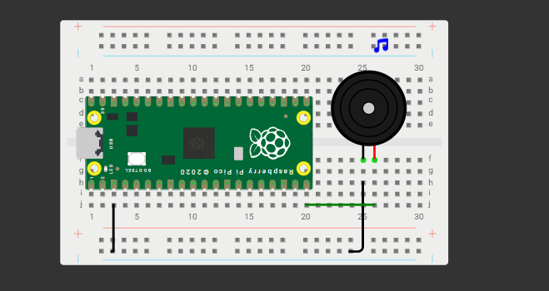

9. IoT based DC motor speed control using Arduino/Raspberry Pi.
Reference Link: https://wokwi.com/projects/462024572818446337
from machine import Pin, PWM, ADC
import time

# 1. DC Motor Setup (GP15)
dc_motor = PWM(Pin(15))
dc_motor.freq(1000)

# 2. Servo Setup (GP16)
servo = PWM(Pin(16))
servo.freq(50) # Servos require exactly 50Hz

# 3. Potentiometer (GP26)
pot = ADC(26)

# Servo pulse helper
def set_servo_duty(angle):
# Map 0-180 degrees to ~1638-8192 duty (0.5ms to 2.5ms)
duty = int(((angle / 180) * 6554) + 1638)
servo.duty_u16(duty)

current_angle = 0
step_direction = 1

while True:
# Read Potentiometer
pot_val = pot.read_u16()

# 1. Update DC Motor Speed
dc_motor.duty_u16(pot_val)

# 2. Calculate Servo "Speed" (Delay)
# Mapping pot to a delay between 0.001s (Fast) and 0.05s (Slow)
# Note: If pot is 0, we stop the servo
speed_delay = (65535 - pot_val) / 1000000 + 0.001

if pot_val > 1000:
# Move servo one step
current_angle += step_direction
if current_angle >= 180 or current_angle <= 0:
step_direction *= -1 # Reverse direction at boundaries

set_servo_duty(current_angle)

speed_percent = int((pot_val / 65535) * 100)
print(f"DC Speed: {speed_percent}% | Servo Speed: {speed_percent}%", end="\r")
else:
print("Motors Stopped... ", end="\r")

time.sleep(speed_delay)
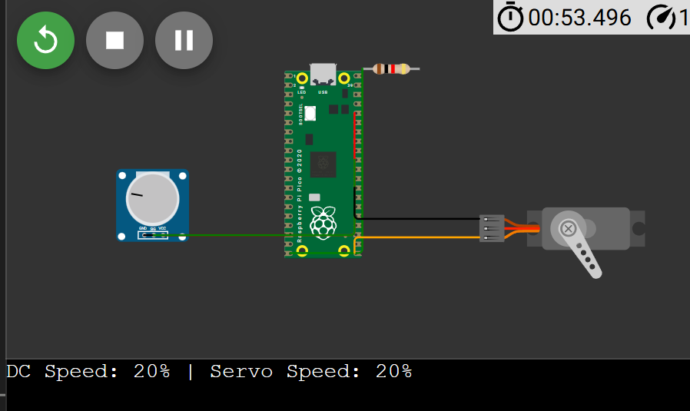
10. To study of IoT Data Logging using Beaglebone Black and Thingspeak
Reference Link: https://wokwi.com/projects/460072555056502785

Hardware Required
Sr. No. | Component | Quantity
1 | BeagleBone Black | 1
2 | USB Cable | 1
3 | Breadboard | 1
4 | Light Dependent Resistor (LDR) | 1
5 | 10 kΩ Resistor | 1
6 | Connecting Wires | As required
7 | PC/Laptop with Internet | 1

Software Required
- Debian Linux on BeagleBone Black
- Python
- Adafruit_BBIO Library
- Internet Connection
- ThingSpeak Account
- SSH Terminal (PuTTY)

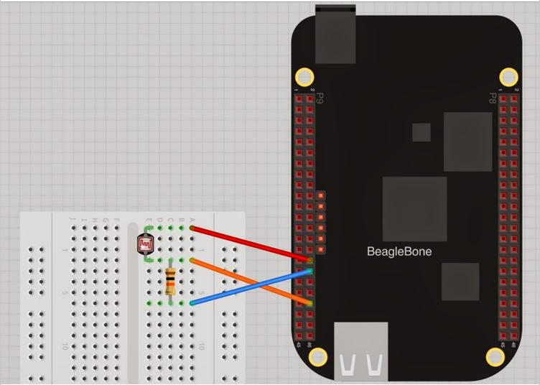
Algorithm
- Start the BeagleBone Black.
- Connect BBB to the Internet.
- Create a ThingSpeak account and a new channel.
- Note the Write API Key.
- Connect the LDR circuit to the analog input.
- Initialize the ADC using the Adafruit_BBIO library.
- Read the analog sensor value.
- Convert the ADC reading into voltage.
- Send the voltage value to ThingSpeak using an HTTP POST request.
- Wait for approximately 15–20 seconds before sending the next reading.
- Repeat the process continuously.
- Observe the real-time graph on ThingSpeak.

Program (Python)
import Adafruit_BBIO.ADC as ADC
import time
import httplib, urllib

sensor_pin = "P9_40"

ADC.setup()

while True:

reading = ADC.read(sensor_pin)
voltage = reading * 1.8

params = urllib.urlencode({
'field1': voltage,
'key': 'YOUR_WRITE_API_KEY'
})

headers = {
"Content-type": "application/x-www-form-urlencoded",
"Accept": "text/plain"
}

conn = httplib.HTTPConnection("api.thingspeak.com:80")
conn.request("POST", "/update", params, headers)

response = conn.getresponse()

print("ADC Reading :", reading)
print("Voltage :", voltage)

time.sleep(16)
Replace YOUR_WRITE_API_KEY with the Write API Key obtained from your ThingSpeak channel. (noobtechiespeaks.blogspot.com)

Working
- The LDR senses the surrounding light intensity.
- The voltage across the LDR changes according to light intensity.
- BeagleBone Black reads this voltage through its Analog-to-Digital Converter (ADC).
- The Python program converts the ADC value into voltage.
- The measured value is uploaded to the ThingSpeak cloud using an HTTP POST request.
- ThingSpeak stores the data and automatically generates graphs for visualization.
- The graph updates every 15–20 seconds with new sensor readings. (noobtechiespeaks.blogspot.com)

Sample Output
ADC Reading : 0.412
Voltage : 0.7416 V

HTTP Response : 200 OK

Data uploaded successfully.

Result
The analog sensor data was successfully acquired using BeagleBone Black and uploaded to the ThingSpeak cloud platform. The sensor readings were stored and displayed as real-time graphs, demonstrating successful IoT-based cloud data logging.

